***BIG DATA ANALYTICS(SWE2011)***

DIGITAL ASSIGNMENT-1

Name:Akshaya Vardhini

Register no.:22MIS1098

Date:06-09-2024

*AIM:*

To create a mapreduce program that returns the number of cancelled/dealyed flights on a particular date from the given dataset.

*TOOLS USED:*

Hadoop-2.7.2

*PROCEDURE:*

1.Create FlightDelayAnalysis.java file

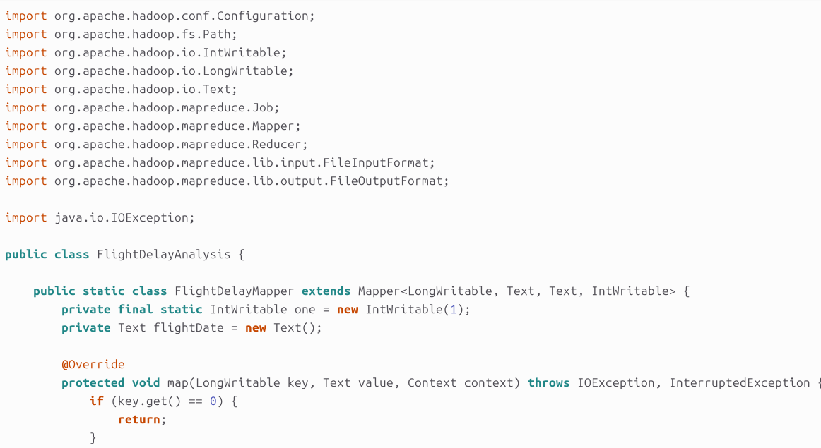

2.Convert the java file into a jar file using terminal

3.Execute the jar file

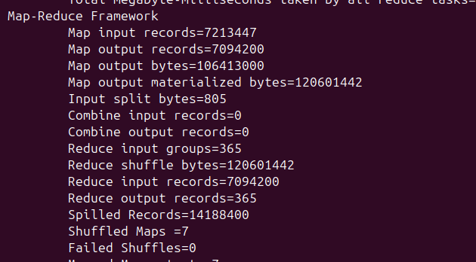

4.View output in the terminal

